Proposal Instructions
Department of Natural Resources
Mike Levine Lakeland Trail 29.2 MILES OF TRAIL TO BE CLEARED FOR ACCESSIBILITY
Request for Proposal No. 260000000891
Solicitation Manager Name: Amanda Pauly
Direct Phone: (517) 388-9905
Email: paulya3@michigan.gov
This is a Request for Proposal (RFP) for:
Mike Levine Lakeland Trail State Park
Mowing and Brushing
RFP Timeline
Event | Time | Date
RFP issue date | N/A | Thursday, January 29, 2026
Registration for Optional preproposal meeting | 5:00 p.m. Eastern | Friday, February 6, 2026
Optional Pre Proposal Meeting | 9:00 a.m. Eastern | Thursday, February 12, 2026
Deadline for bidders to submit questions about this RFP | 4:00 p.m. Eastern | Monday, February 23, 2026
Anticipated date the State will post answers to bidder questions on www.michigan.gov/SIGMAVSS | 5:00 p.m. Eastern | Monday, March 2, 2026
Proposal deadline* | 9:30 a.m. Eastern | Friday, March 13, 2026
Anticipated contract begin date | N/A | Monday, June 1, 2026
*A bidder’s proposal received at 9:30:01 a.m. Eastern is late and subject to disqualification.
This RFP is subject to change. Check www.michigan.gov/SIGMAVSS for current information.

- PROPOSAL PREPARATION. The State recommends reading all RFP materials prior to preparing a proposal, particularly these Proposal Instructions and the Vendor Questions Worksheet. Bidders must follow these Proposal Instructions and provide a complete response to the items indicated in the RFP Structure and Documentation table below. References and links to websites or external sources may not be used in lieu of providing the information requested in the RFP within the proposal. Include the bidder’s company name in the header of all documents submitted with your proposal. Note that all documents and information submitted as part of a proposal will become public record immediately upon receipt by the State. Proposals received by the State may be posted on the State’s publicly available website after bidders are notified of the award recommendation.
RFP Structure and Documentation
Document | Description | Bidder Response Instructions
Cover Page | Provides RFP title and number, important dates, and contact information for Solicitation Manager | Informational
Proposal Instructions | Provides RFP instructions to bidders | Informational
Confidential Treatment Form | Required verification on whether bidder’s proposal contains confidential information | Bidder to complete and submit by proposal deadline
Vendor Questions Worksheet | Questions to bidders on background and experience | Bidder to complete and submit by proposal deadline
Contract Terms | Provides legal terms for a contract awarded through this RFP | Deemed accepted by bidder unless information required in the Evaluation Process section of this document is submitted by proposal deadline
Schedule A – Statement of Work | Statement of work | Bidder to complete and submit by proposal deadline
Schedule B – Pricing | Pricing for goods and services sought by the State through this RFP | Bidder to complete and submit by proposal deadline
Exhibit A | Trail Information, Diagram and Map | Informational
- CONTACT INFORMATION FOR THE STATE. The sole point of contact for the State concerning this RFP is listed on the Cover Page. Contacting any other State personnel, agent, consultant, or representative about this RFP may result in bidder disqualification.
- OPTIONAL PRE-PROPOSAL ON SITE MEETING.
An optional meeting will take place on Thursday, February 12, 2026, at 9:00, for approximately an hour. Vendors must register by emailing paulya3@michigan.com by 5 p.m. on Friday, February 6, 2026. If we receive no registrations, there will be no walk through. If the walkthrough is not able to be completed due to weather/trail conditions, we will reschedule it for the following week.
The pre-proposal on site meeting will be scheduled as a drive through visit, you would follow behind the lead vehicle. However, if the weather does not cooperate it will be a meeting that will have a beginning and alternative ending point. You will receive information on the starting and ending points when you register.
You can request a special permit to use a vehicle and complete the trail on your own, you would need to request by emailing paulya3@michigan.com with a proposed date, if it is approved, you will be issued a permit, it will be valid only for the date and time listed on it. If that date does not work for the location due to high traffic volume or other unforeseen events, you will be contacted with alternative dates. (The permits for vehicle use may be revoked at any time due to weather/trail conditions. Please email Amanda Pauly at paulya3@michigan.gov or call 517-338-9905 the day of the permit to ensure it is still valid)
You can, at any time, walk, bike, horseback, cross-country ski or snowshoe the trail, no motorized vehicles of any size are allowed on the trail. (Excluding the obtaining of the special permit for the time period listed on the permit and it is still valid.)
- MODIFICATIONS. The State may modify this RFP at any time. Modifications will be posted on www.michigan.gov/SIGMAVSS. This is the only method by which the RFP may be modified.
- QUESTIONS. Bidder questions about this RFP must be emailed to the Solicitation Manager no later than the time and date specified on the Cover Page. In the interest of transparency, only written questions are accepted. Answers to questions will be posted on www.michigan.gov/SIGMAVSS. Submit questions using the format below; a Microsoft Excel format or similar is suggested.
Q # | Document and Section | Page # | Bidder Question
- DELIVERY OF PROPOSAL.
Electronic – The bidder must submit its proposal, all attachments, and any modifications or withdrawals electronically through www.michigan.gov/SIGMAVSS. The price proposal should be saved separately from all other proposal documents. The bidder should submit all documents in a modifiable (native) format (examples include but are not limited to Microsoft Word or Excel and Google Docs or Sheets). In addition to submitting documents in a modifiable format, the bidder may also submit copies of documents in PDF. Attachment file size is limited to 30 MB per document. Bidder’s failure to submit a proposal as required may result in disqualification. The proposal and attachments must be fully uploaded and submitted prior to the proposal deadline. Do not wait until the last minute to submit a proposal, as the SIGMA VSS system requires the creation of an account and entry of certain information, in addition to uploading and submitting the materials. The SIGMA VSS system will not allow a proposal to be submitted after the proposal deadline identified in the solicitation Closing On/Closing Date fields (Summary view/Detail view), even if a portion of the proposal has been uploaded.
Questions on how to submit information or how to navigate in the SIGMA VSS system can be answered by calling (517) 284-0540 or (888) 734-9749. The Solicitation Manager will not provide assistance related to the submittal of the proposal and all attachments on the day of the proposal deadline. Responsibility for a complete submission lies with the bidder. Note that all documents and information submitted in any manner as part of a proposal will become public record immediately upon receipt by the State. Proposals received may be posted by the State on the State’s publicly available website after bidders are notified of the award recommendation.
- EVALUATION PROCESS. The State will evaluate each proposal based on the following factors:
Contractor will comply as specified with no exceptions: PASS
Contractor has noted exceptions to specifications:
- PASS if the exception(s), at the sole discretion of the State, is evaluated as acceptable.
- FAIL if the exception(s), at the sole discretion of the State, is evaluated as unacceptable.
 | Technical Evaluation Criteria | Pass/Fail
1. | General Requirements – Schedule A; Statement of Work, Sections 1-2
2. | Service Requirements – Schedule A; Statement of Work, Sections 2
3. | Staffing – Schedule A; Statement of Work, Staffing Sections 3
4. | Project Management– Schedule A; Statement of Work, Sections 4
5. | Pricing, Ordering – Schedule A; Statement of Work, Sections 5-6
5. | Invoicing and Payments, Liquid Damages – Schedule A; Statement of Work, Section 7-8
6. | Vendor Questions Worksheet
Proposals receiving Pass/Fail or more technical evaluation points will have pricing evaluated and considered for award.
The State may utilize all bidder information, without regard to a proposal’s technical score, to determine fair market value for goods or services sought. The State is not obligated to accept the lowest price proposal. If applicable, the State’s evaluation will include consideration of a bidder’s qualified disabled veterans/service-disabled veteran owned business(QDV/SDVOB) status under MCL 18.1261(8). Additional information on the SDVOB preference is available at: Michigan.gov/SDVOB.
The State strongly encourages strict adherence to the Contract Terms. The State reserves the right to deem a bid non-responsive for failure to accept the Contract Terms. Nevertheless, the bidder may submit proposed changes to the Contract Terms in track changes (i.e., visible edits) with an explanation of the bidder’s need for each proposed change. Failure to include track changes with an explanation of the bidder’s need for the proposed change constitutes the bidder’s acceptance of the Contract Terms. General statements, such as that the bidder reserves the right to negotiate the terms and conditions, may be considered non-responsive. Failure to respond timely to requests for proposed changes to Contract Terms during ongoing negotiations may be cause for disqualification.
The State may but is not required to conduct an on-site visit to tour and inspect the bidder’s facilities; require an oral presentation of the bidder's proposal; conduct interviews, research, reference checks, and background checks; and request additional price concessions at any point during the evaluation process.
- NOTICE OF DEFICIENCY. The State reserves the right to issue a Notice of Deficiency to bidders if the State determines after the proposal deadline that a portion of the RFP was deficient, unclear, or ambiguous. Failure to respond to a Notice of Deficiency timely may be cause for disqualification.
- CLARIFICATION REQUEST. The State reserves the right to issue a Clarification Request to a bidder to clarify its proposal if the State determines the proposal is not clear. Failure to respond to a Clarification Request timely may be cause for disqualification.
- RESERVATIONS. The State reserves the right to:
  - Disqualify a bidder for failure to follow these instructions.
  - Discontinue the RFP process at any time for any or no reason. The issuance of an RFP, your preparation and submission of a proposal, and the State’s subsequent receipt and evaluation of your proposal does not commit the State to award a contract to you or anyone, even if all the requirements in the RFP are met.
  - Consider late proposals if: (i) no other proposals are received; (ii) no complete proposals are received; (iii) the State received complete proposals, but the proposals did not meet mandatory minimum requirements or technical criteria; or (iv) the award process fails to result in an award.
  - Consider an otherwise disqualified proposal if no other proposals are received.
  - Disqualify a proposal based on: (i) information provided by the bidder in response to this RFP; (2) the bidder’s failure to complete registration on www.michigan.gov/SIGMAVSS ; or (3) if it is determined that a bidder purposely or willfully submitted false or misleading information in response to the RFP.
  - Consider prior performance with the State in making its award decision.
  - Consider overall economic impact to the State when evaluating proposal pricing and in the final award recommendation. This includes but is not limited to: considering principal place of performance, number of Michigan citizens employed or potentially employed, dollars paid to Michigan residents, Michigan capital investments, job creation, tax revenue implications, and economically disadvantaged businesses.
  - Consider total-cost-of-ownership factors (e.g., transition and training costs) when evaluating proposal pricing and in the final award recommendation.
  - Refuse to award a contract to any bidder that has failed to pay State taxes or has outstanding debt with the State.
  - Enter into negotiations with one or more bidders on price, terms, technical requirements, or other deliverables.
  - Award multiple, optional-use contracts, or award by Contract Activity.
  - Evaluate the proposal outside the scope identified in the Evaluation Process section of this document if the State receives only one proposal.
- AWARD RECOMMENDATION. The contract will be awarded to the responsive and responsible bidder who offers the best value to the State, as determined by the State. Best value will be determined by the bidder meeting the minimum point threshold and offering the best combination of the factors stated in the Evaluation Process section of this document, and price, as demonstrated by the proposal. The State will post an Award Recommendation and Evaluation Synopsis on www.michigan.gov/SIGMAVSS or in the manner it was originally published.
- DEBRIEF MEETING AND BID PROTEST. The State will publish an Award Recommendation and Evaluation Synopsis which will provide instructions on how to request a debrief meeting.
If you wish to initiate a protest of the award, you must submit your written protest to pauly3@michigan.gov no later than 4:00p.m., 3 business days after the Award Recommendation and Evaluation Synopsis is posted on SIGMA VSS. The State reserves the right to adjust this timing and will publish any change.
Additional information about the protest process is available at DTMB - Programs and Policies (michigan.gov) under the “Bidder Protests” link.
- STATE ADMINISTRATIVE BOARD. Contracts equal to $250,000 or greater than require approval by the State Administrative Board. The State Administrative Board’s decision is final; however, its approval does not constitute a contract. The award process is not complete until the awarded contractor receives a contract fully executed by all parties.
- GENERAL CONDITIONS. The State will not be liable for any costs, expenses, or damages incurred by a bidder participating in this solicitation. The bidder agrees that its proposal will be considered an offer to do business with the State in accordance with its proposal, including the Contract Terms, and that its proposal will be irrevocable and binding for a period of [180] calendar days from date of submission. If a contract is awarded to the bidder, the State may, at its option, incorporate any part of the bidder’s proposal into a contract. This RFP is not an offer to enter into a contract. This RFP may not provide a complete statement of the State’s environment or contain all matters upon which agreement must be reached. The bidder understands that their proposal will become public record immediately upon receipt by the State. Other than verified trade secrets, proposals submitted via www.michigan.gov/SIGMAVSS are the State’s property.
- CONFIDENTIAL TREATMENT FORM AND THE FREEDOM OF INFORMATION ACT. As a public record, all portions of the bidder’s proposal and resulting contract are subject to disclosure as required under Michigan’s Freedom of Information Act (FOIA), MCL 15.231, et seq. However, the State may exempt some information from disclosure as permitted by law. Under MCL 18.1261(13)(b), records containing “a trade secret as defined under section 2 of the uniform trade secrets act, 1998 PA 448, MCL 445.1902,” are exempt from disclosure under FOIA. In addition, “financial or proprietary information” submitted with a bidder’s proposal is exempt from disclosure under FOIA. A bidder’s failure to comply with this Section is grounds for rejecting a bidder’s proposal as non-responsive. As a part of its proposal, each bidder must follow the procedure below.
  - SUBMIT A COMPLETED CONFIDENTIAL TREATMENT FORM WITH YOUR BID. Completion and submission of the Confidential Treatment Form (CT Form) is required regardless of whether the bidder seeks confidential treatment of information. Failure to submit a completed CT Form may be cause for disqualification from the solicitation process. If a bidder fails to properly complete and submit the CT Form or otherwise fails to follow CT Form instructions, the proposal may be publicly disclosed in its entirety without redaction after an award recommendation.
    - Complete and sign Section 1 of the CT Form if the bidder does NOT request confidential treatment of information contained in its proposal; or
    - Complete and sign Section 2 of the CT Form if the bidder requests confidential treatment of certain information. Bidder must also submit a copy of the proposal with the trade secret, financial, and proprietary information redacted and clearly labeled as the “PUBLIC COPY.”
    - Failure to complete and sign a CT Form may result in disqualification of the bidder. If a bidder fails to properly complete and submit the CT Form or otherwise fails to follow the CT Form instructions, the proposal, in its entirety, may be publicly disclosed by the State without redaction after an award recommendation.
  - FOIA REQUESTS. If a FOIA request is made for a bidder’s proposal, the Public Copy may be distributed to the public along with the bidder’s CT Form. The CT Form is a public document and serves as an explanation for the redactions to the Public Copy. Do not put any trade secret, financial, or proprietary information in the CT Form. Do not redact the CT Form itself.
  - NO ADVICE. The State will not advise a bidder as to the nature or content of documents entitled to protection from disclosure under FOIA or other laws, as to the interpretation of such laws, or as to the definition of trade secret or financial or proprietary information. Nothing contained in this provision will modify or amend requirements and obligations imposed on the State by FOIA or other applicable law. The State is not obligated to notify a bidder if a FOIA request for bidder’s proposal is received nor if bidder’s proposal is made available to the public.
  - FAILURE TO REQUEST CONFIDENTIAL TREATMENT. Failure to request material be treated as confidential as specified herein relieves the State, its agencies, and personnel from any responsibility for maintaining material in confidence.
  - Bids containing a request to maintain an entire proposal as confidential may be rejected as non-responsive. Bidders may not request confidential treatment with respect to resumes, pricing, and marketing materials. The State reserves the right to determine whether material designated as exempt by a bidder falls under MCL 18.1261 or other applicable FOIA exemptions. If a FOIA request is made for materials that the bidder has identified as trade secret, financial, or proprietary information, the State has the final authority to determine whether the materials are exempt from disclosure under FOIA.
  - Bidder forever releases the State, its departments, subdivisions, officers, and employees from all claims, rights, actions, demands, damages, liabilities, expenses and fees, which arise out of or relate to the disclosure of all or a portion of bidder’s proposal submitted under this RFP. Bidder must defend, indemnify and hold the State, its departments, subdivisions, officers, and employees harmless, without limitation, from and against all actions, claims, losses, liabilities, damages, costs, attorney fees, and expenses (including those required to establish the right to indemnification), arising out of or relating to any FOIA request, including potential litigation and appeals, related to the portion of bidder’s proposal submitted under this RFP that bidder has identified as a trade secret, or financial or proprietary information. The State will notify bidder in writing if indemnification is sought. The State is entitled to: (i) regular updates on proceeding status; (ii) participate in the defense of the proceeding; (iii) employ its own counsel; and to (iv) retain control of the defense, or any portion thereof, if the State deems necessary. Bidder will not, without the State’s written consent (not to be unreasonably withheld), settle, compromise, or consent to the entry of any judgment in or otherwise seek to terminate any claim, action, or proceeding. If a State employee, official, or law is involved or challenged, the State may control the defense of that portion of the claim. Any litigation activity on behalf of the State, or any of its subdivisions under this Section, must be coordinated with the Department of Attorney General. An attorney designated to represent the State may not do so until approved by the Michigan Attorney General and appointed as a Special Assistant Attorney General.

Confidential Treatment Form
INSTRUCTIONS. A signed and dated Confidential Treatment Form (CT Form) must be submitted with your proposal, regardless of whether your proposal contains confidential information.
- Complete either Section 1 or Section 2 of this form and sign where indicated. Do not complete both sections. Note: Completion of Section 2 is required to request confidential treatment.
- This form must be signed by the individual who signed the bidder’s proposal.
Failure to submit a completed CT Form with your bid is grounds for rejecting the proposal as non-responsive.
In addition, failure to follow the instructions on this form or to properly complete and submit it may result in the entire proposal being publicly disclosed by the State without redaction after an award recommendation.
See the Confidential Treatment Form and the Freedom of Information Act section of the Proposal Instructions for additional information.
Section 1. CONFIDENTIAL TREATMENT IS NOT REQUESTED
This section must be completed, signed, and submitted with the proposal if the bidder does not request confidential treatment of any material contained in the proposal. If this section is completed, do not complete Section 2.
By signing below, the bidder affirms that confidential treatment of material contained in their proposal is not requested.
RFP Number |  | RFP Title
Signature |  | Date
Printed Name, Title, Company
Section 2. CONFIDENTIAL TREATMENT IS REQUESTED
Bidders must complete, sign, and submit this section with the proposal, to request confidential treatment of any material contained in the proposal. If this section is completed, do not complete Section 1.
Bidders must specifically identify the information to be protected as confidential and/or proprietary and state the reasons why protection is necessary. As shown in the table below, the following details are required for each confidentiality request.
- The proposal page number, section number, and paragraph number.
- Whether the material referenced is Trade Secret (TS), Proprietary Financial Information (FI), or Proprietary Information (PI). Bidders may not request confidential treatment of resumes, pricing, and marketing materials.
- An explanation of the specific legal grounds that support treatment of the material as TS, FI, or PI and a complete justification as to how the material falls within the scope of an applicable FOIA exemption or relevant case law. Bidders must not simply cite an applicable exemption or case name.
- The person at their organization authorized to respond to inquiries by the State concerning the material and their contact information.
REQUIRED: Bidders completing this section must also submit a copy of the proposal with the trade secret, financial, and proprietary information redacted and clearly label this redacted copy as the PUBLIC COPY.
(1)  Proposal Page #, Section #, Paragraph # | (2)  Material is Trade Secret (TS), Proprietary Financial Information (FI), Proprietary Information (PI) | (3)  Applicable FOIA Exemption with Written Justification | (4)  Bidder Contact Information
Bidders may add rows or additional pages using the same format shown in the table.
State of Michigan FOIA Requests
The State reserves the right to determine whether material designated as exempt by a bidder falls under MCL 18.1261 or other applicable FOIA exemptions.
If a FOIA request is made for materials that the bidder has identified as trade secret, financial, or proprietary information, the State has the final authority to determine whether the materials are exempt from disclosure under FOIA.
The State is not obligated to notify a bidder if a FOIA request for bidder’s proposal is received nor if bidder’s proposal is made available to the public. This form, and any additional justification letters, are not exempt from release under FOIA.
By signing below, the bidder affirms that confidential treatment of material contained in their proposal is requested and has attached to this form a redacted “Public Copy” of the bidder’s proposal.
RFP Number |  | RFP Title
Signature |  | Date
Printed Name, Title, Company

Vendor Questions Worksheet
Provide a detailed response to each question. “You” and “company” refers to the bidder.
Information Sought | Bidder Response
- Contact Information
Bidder’s sole contact person during the RFP process. Include name, title, address, email, and phone number.
Person authorized to receive and sign a resulting contract. Include name, title, address, email, phone number and vendor customer code in SIGMA VSS.
- Company Background Information
Legal business name and address. Include business entity designation, e.g., sole proprietor, Inc., LLC, or LLP.
What state was the company formed in?
Phone number.
Website address.
Number of years in business.
Number of employees.
Legal business name and address of parent company, if any.
Has there been a recent change in organizational structure (e.g., management team) or control (e.g., merger or acquisition) of your company? If the answer is yes: (a) explain why the change occurred and (b) how this change has affected your company.
Discuss your company’s history. Has growth been organic, through mergers and acquisitions, or both?
Has bidder ever been debarred, suspended, or disqualified from bidding or contracting with any entity, including the State of Michigan? If yes, provide the date, the entity, and details about the situation.
Has your company been a party to litigation against the State of Michigan? If the answer is yes, then state the date of initial filing, case name and court number, and jurisdiction.
Within the last 5 years, has your company or any of its related business entities defaulted on a contract or had a contract terminated for cause? If yes, provide the date, contracting entity, type of contract, and details about the termination or default.
State your gross annual sales for each of the last 5 years.
If receiving a contract under this RFP will increase your gross revenue by more than 25% from last year’s sales, explain how the company will scale-up to manage this increase.
Describe partnerships and strategic relationships you think will bring significant value to the State.
State the physical address of the place of business that would have primary responsibility for this account if bidder is awarded a contract under this RFP.
Bidder affirms that any business types identified on its SIGMA VSS profile, including those eligible for Geographically Disadvantaged Business Enterprise (GDBE) and Michigan Supplier Community Program (MiSC), are valid. | Choose an item.
- Qualified Disabled Veteran/Service-Disabled Veteran-Owned Business Program
Under MCL 18.1261, a “qualified disabled veteran” means a business entity that is 51% or more owned by 1 or more veterans with a service-connected disability. A “service-connected disability” means a disability incurred or aggravated in the line of duty in the active military, naval, or air service as described in 38 USC 101(16). Are you a qualified disabled veteran? | Choose an item.
To demonstrate qualification as a qualified disabled veteran, you must provide:  (a) Proof of service and conditions of discharge (DD214 or equivalent);  (b) Proof of service-connected disability (DD214 if the disability was documented at discharge or Veterans Administration Rating Decision Letter or equivalent if the disability was documented after discharge); and  (c) Legal documents setting forth the ownership of the business entity.  In lieu of the documentation identified above, you may provide proof of certification by the National Veterans Business Development Council. | Enter the names of documents submitted with your proposal to demonstrate status as a qualified disabled veteran.
- Participation in RFP Development or Evaluation
Did your company, an employee, agent, or representative of your company, or any affiliated entity participate in developing any component of this solicitation? For purposes of this question, business concerns, organizations, or individuals are affiliates of each other if, directly or indirectly: (1) either one controls or has power to control the other or (2) a third-party controls or has the power to control both. Indicia of control include, but are not limited to, interlocking management or ownership, identity of interests among family members, shared facilities or equipment, and common use of employees. | Choose an item.  If you enter “YES”, you are not eligible for contract award or to work as a subcontractor for the awarded vendor.
If you are awarded a contract under this solicitation, in order to provide the goods or services required under a resulting contract, do you intend to partner or subcontract with a person or entity that assisted in the development of this solicitation? | Choose an item.  If you enter “YES,” you are not eligible for contract award. An awarded vendor may not partner or subcontract with anyone to provide goods and services required under a resulting contract if that subcontractor or partner assisted in the development of this solicitation.
Will your company, or an employee, agent, or representative of your company, participate in the evaluation of the proposals received in response to this RFP? | Choose an item.  If you enter “YES”, you are not eligible for contract award or to work as a subcontractor for the awarded vendor.
- State of Michigan Experience and Prior Experience
Does your company have experience working with the State of Michigan? If so, please provide a list (including the contract number) of the contracts you hold or have held with the State for the last 10 years.
Describe at least [3] relevant experiences from the last [5] years supporting your ability to successfully manage a contract of similar size and scope for the work described in this RFP.
Experience 1
Company name.
Contact name.
Contact role at time of project.
Contact phone.
Contact email.
City.
State.
Zip.
1. Project name and description of the scope of the project.
2. What role did your company play?
3. How is this project experience relevant to the subject of this RFP?
Dollar value.
Start and end date (mm/yy – mm/yy)
Status (completed, live, other – specify phase)
Results obtained.
Experience 2
Company name.
Contact name.
Contact role at time of project.
Contact phone.
Contact email.
City.
State.
Zip.
1. Project name and description of the scope of the project.
2. What role did your company play?
3. How is this project experience relevant to the subject of this RFP?
Dollar value.
Start and end date (mm/yy – mm/yy)
Status (completed, live, other – specify phase)
Results obtained.
Experience 3
Company name.
Contact name.
Contact role at time of project.
Contact phone.
Contact email.
City.
State.
Zip.
1. Project name and description of the scope of the project.
2. What role did your company play?
3. How is this project experience relevant to the subject of this RFP?
Dollar value.
Start and end date (mm/yy – mm/yy)
Status (completed, live, other – specify phase)
Results obtained.
- Standard Contract Terms
Bidder must affirm agreement with the attached Contract Terms. If not in agreement, written exceptions in accordance with the Evaluation Process section of the Proposal Instructions must be provided with Bidder’s proposal.
- Insurance Requirements
Bidder must affirm agreement with the attached Schedule C (Insurance Requirements). If not in agreement, written exceptions in accordance with the Evaluation Process section of the Proposal Instructions must be provided with the Bidder’s proposal. | Choose an item.
- Michigan Voluntary Protection Program
Bidder must verify if their company is recognized in the Michigan Voluntary Protection Program (MVPP) | Choose an item.
- Michigan Economic Impact
Number of employees currently employed at locations within the State of Michigan.
Number of additional employees to be employed at locations within the State of Michigan if awarded this Contract (if any)
Minimum wage paid to employees employed at locations within the State of Michigan.
Average wage paid to employees employed at locations within the State of Michigan.
Percentage of employees employed at locations within the State of Michigan that are covered by employer-provided health insurance.
- Labor, Antidiscrimination and Environmental Laws Compliance
Bidder must disclose any violations of state or federal labor, antidiscrimination and employment laws and regulations received within the past five years.
Bidder must disclose any violations of state or federal environmental laws and regulations received within the past five years.
- Other
Classification of Employees. I certify that the company has properly classified its employees in accordance with federal/state labor and employment laws. | Choose an item.
Certification of Michigan Business- Public Act 431 of 1984, Sec. 268. I certify that the company has, pursuant to the provisions of Sec 268 of Public Act 431 of 1984, filed a Michigan Business Tax Corporate Income Tax Return. I certify that the company has, pursuant to the provisions of Sec 268 of Public Act 431 of 1984, filed a Michigan Income Tax return showing income generated in, or attributed to the State of Michigan. I certify that the company has, pursuant to the provisions of Sec 268 of Public Act 431 of 1984, withheld Michigan Income Tax from compensation paid to the company’s owners and remitted the tax to the Michigan Department of Treasury. | Choose an item.
Iran Linked Business- Public Act 517 of 2012. I certify that the Company is not an Iran-Linked business as defined by Public Act 517 of 2012. | Choose an item.
Clean Corporate Citizen. I certify that the Company is a Clean Corporate Citizen as defined by the Environmental Protection Act, 1994 PA 451. | Choose an item.
Convict Labor. The Contractor certifies that if using convict labor, it is complying with all applicable state and federal laws and policies. | Choose an item.
SOM Debt/Tax Payment. All SOM tax/debts. I certify that all applicable State of Michigan taxes are paid, and that no outstanding debt is owed to the State of Michigan. | Choose an item.
Authorization to Verify Information Provided by Vendor. I authorize the State to verify that all information provided in this registration, in bidding and contracting documents, and any attachments or supplement documents and processes are accurate. | Choose an item.
- Response to State Requests
Bidder agrees to respond, by established deadlines, to all requests from the State including but not limited to, clarification requests, notices of deficiency, and proposed changes to Contract Terms. | Choose an item.

Standard Contract Terms
This STANDARD CONTRACT (“Contract”) is agreed to between the State of Michigan (the “State”) and [Insert Company Name] (“Contractor”), a [Insert State & Entity Status, e.g., a Michigan corporation or a Texas limited liability company]. This Contract is effective on [Month, Day, Year] (“Effective Date”), and unless terminated, will expire on [Month, Day, Year] (the “Term”).
The parties agree as follows:
- Duties of Contractor. Contractor must perform the services and provide the deliverables (the “Contract Activities”) described in a Statement of Work, the initial Statement of Work is attached as Schedule A – Statement of Work. An obligation to provide delivery of any commodity is considered a service and is a Contract Activity.
Contractor must furnish all labor, equipment, materials, and supplies necessary for the performance of the Contract Activities unless otherwise specified in a Statement of Work.
Contractor must: (a) perform the Contract Activities in a timely, professional, safe, and workmanlike manner consistent with standards in the trade, profession, or industry; (b) meet or exceed the performance and operational standards, and specifications of the Contract; (c) provide all Contract Activities in good quality, with no material defects; (d) not interfere with the State’s operations; (e) obtain and maintain all necessary licenses, permits or other authorizations necessary for the performance of the Contract; (f) cooperate with the State, including the State’s quality assurance personnel, and any third party to achieve the objectives of the Contract; (g) return to the State any State-furnished equipment or other resources in the same condition as when provided when no longer required for the Contract; (h) assign to the State any claims resulting from state or federal antitrust violations to the extent that those violations concern materials or services supplied by third parties toward fulfillment of the Contract; (i) comply with all State physical and IT security policies and standards which will be made available upon request; and (j) provide the State priority in performance of the Contract except as mandated by federal disaster response requirements. Any breach under this paragraph is considered a material breach.
Contractor must also be clearly identifiable while on State property by wearing identification issued by the State, and clearly identify themselves whenever making contact with the State.
- Notices. All notices and other communications required or permitted under this Contract must be in writing and will be considered given and received: (a) when verified by written receipt if sent by courier; (b) when actually received if sent by mail without verification of receipt; or (c) when verified by automated receipt or electronic logs if sent by facsimile or email.
If to State: | If to Contractor:
See Contract Administrator information shown below. | [Name]  [Street Address]  [City, State, Zip]  [Email]  [Phone]
- Contract Administrator. The Contract Administrator, or the individual duly authorized for each party, is the only person authorized to modify any terms of this Contract, and approve and execute any change under this Contract (each a “Contract Administrator”):
State: | Contractor:
Amanda Pauly  525 W. Allegan  Lansing, MI 48913  Paulya3@michigan.gov  517-388-9905 | [Name]  [Street Address]  [City, State, Zip]  [Email]  [Phone]
- Program Manager. The Program Manager for each party will monitor and coordinate the day-to-day activities of the Contract (each a “Program Manager”):
State: | Contractor:
Charles Dennison  8555 SILVER HILL  PINCKNEY MI 48169  DennisonC@michigan.gov  734-426-4913 | [Name]  [Street Address]  [City, State, Zip]  [Email]  [Phone]
- Performance Guarantee. Contractor must at all times have financial resources sufficient, in the opinion of the State, to ensure performance of the Contract and must provide proof upon request. The State may require a performance bond (as specified in a Statement of Work) if, in the opinion of the State, it will ensure performance of the Contract.
- Insurance Requirements.
- General Requirements. Contractor, at its sole expense, must maintain the insurance coverage as specified herein for the duration of the Term. Minimum limits may be satisfied by any combination of primary liability, umbrella or excess liability, and self-insurance coverage. To the extent damages are covered by any required insurance, Contractor waives all rights against the State for such damages. Failure to maintain required insurance does not limit this waiver.
- Qualification of Insurers. Except for self-insured coverage, all policies must be written by an insurer with an A.M. Best rating of A- VII or higher unless otherwise approved by DTMB Enterprise Risk Management.
- Primary and Non-Contributory Coverage. All policies for which the State of Michigan is required to be named as an additional insured must be on a primary and non-contributory basis.
- Claims-Made Coverage. If any required policies provide claims-made coverage, Contractor must:
  - Maintain coverage and provide evidence of coverage for at least 3 years after the later of the expiration or termination of the Contract or the completion of all its duties under the Contract;
  - Purchase extended reporting coverage for a minimum of 3 years after completion of work if coverage is cancelled or not renewed, and not replaced with another claims-made policy form with a retroactive date prior to the Effective Date of this Contract
- Proof of Insurance
  - Insurance certificates showing evidence of coverage as required herein must be submitted to the Contract Administrator within 10 days of the contract execution date.
  - Renewal insurance certificates must be provided on annual basis or as otherwise commensurate with the effective dates of coverage for any insurance required herein.
  - Insurance certificates must be in the form of a standard ACORD Insurance Certificate unless otherwise approved by DTMB Enterprise Risk Management.
  - All insurance certificates must clearly identify the Contract Number (e.g., notated under the Description of Operations on an ACORD form).
  - The State may require additional proofs of insurance or solvency, including but not limited to policy declarations, policy endorsements, policy schedules, self-insured certification/authorization, and balance sheets.
  - In the event any required coverage is cancelled or not renewed, Contractor must provide written notice to the Contract Administrator no later than 5 business days following such cancellation or nonrenewal.
- Subcontractors. Contractor is responsible for ensuring its subcontractors carry and maintain insurance coverage.
- Limits of Coverage & Specific Endorsements. (See Table 6.1 Below)
TABLE 6.1
Required Limits | Additional Requirements
Commercial General Liability Insurance
Minimum Limits:  $1,000,000 Each Occurrence  $1,000,000 Personal & Advertising Injury  $2,000,000 Products/Completed Operations  $2,000,000 General Aggregate | Contractor must have their policy endorsed to add “the State of Michigan, its departments, divisions, agencies, offices, commissions, officers, employees, and agents” as additional insureds using endorsement CG 20 10 11 85, or both CG 20 10 12 19 and CG 20 37 12 19.
Umbrella or Excess Liability Insurance
Minimum Limits:  $5,000,000 General Aggregate | Contractor must have their policy follow form.
Automobile Liability Insurance
Minimum Limits:  $1,000,000 Per Accident | Contractor must have their policy: (1) endorsed to add “the State of Michigan, its departments, divisions, agencies, offices, commissions, officers, employees, and agents” as additional insureds; and (2) include Hired and Non-Owned Automobile coverage.
Workers' Compensation Insurance
Minimum Limits:  Coverage according to applicable laws governing work activities. | Waiver of subrogation, except where waiver is prohibited by law.
Employers Liability Insurance
Minimum Limits:
$500,000 Each Accident
$500,000 Each Employee by Disease
$500,000 Aggregate Disease
- Non-Waiver. This Section 6 is not intended to and is not to be construed in any manner as waiving, restricting or limiting the liability of either party for any obligations under this Contract, including any provisions hereof requiring Contractor to indemnify, defend and hold harmless the State.
- Reserved
- Reserved
- Relationship of the Parties. The relationship between the parties is that of independent contractors. Contractor, its employees, and agents will not be considered employees of the State. No partnership or joint venture relationship is created by virtue of this Contract. Contractor, and not the State, is responsible for the payment of wages, benefits and taxes of Contractor’s employees and any subcontractors. Prior performance does not modify Contractor’s status as an independent contractor. Neither party has authority to contract for nor bind the other party in any manner whatsoever.
- Reserved
- Subcontracting. Contractor may not delegate any of its obligations under the Contract without the prior written approval of the State. Contractor must notify the State at least 90 calendar days before the proposed delegation and provide the State any information it requests to determine whether the delegation is in its best interest. If approved, Contractor must: (a) be the sole point of contact regarding all contractual matters, including payment and charges for all Contract Activities; (b) make all payments to the subcontractor; and (c) incorporate the terms and conditions contained in this Contract in any subcontract with a subcontractor. Contractor remains responsible for the completion of the Contract Activities, compliance with the terms of this Contract, and the acts and omissions of the subcontractor. The State, in its sole discretion, may require the replacement of any subcontractor.
- Staffing. The State’s Contract Administrator may require Contractor to remove or reassign personnel providing services by providing a notice to Contractor.
- Background Checks. Pursuant to Michigan law, all agencies subject to IRS Pub. 1075 are required to ask the Michigan State Police to perform fingerprint background checks on all employees, including Contractor and Subcontractor employees, who may have access to any database of information maintained by the federal government that contains confidential or personal information, including, but not limited to, federal tax information. Further, pursuant to Michigan law, any agency described above is prohibited from providing Contractors or Subcontractors with the result of such background check. For more information, please see Michigan Public Act 427 of 2018. Upon request, or as may be specified in a Statement of Work, Contractor must perform background checks on all employees and subcontractors and its employees prior to their assignment. The scope is at the discretion of the State and documentation must be provided as requested. Contractor is responsible for all costs associated with the requested background checks. The State, in its sole discretion, may also perform background checks.
- Assignment. Contractor may not assign this Contract to any other party without the prior approval of the State. Upon notice to Contractor, the State, in its sole discretion, may assign in whole or in part, its rights or responsibilities under this Contract to any other party. If the State determines that a novation of the Contract to a third party is necessary, Contractor will agree to the novation and provide all necessary documentation and signatures.
- Change of Control. Contractor will notify the State, within 30 days of any public announcement or otherwise once legally permitted to do so, of a change in Contractor’s organizational structure or ownership. For purposes of this Contract, a change in control means any of the following: (a) a sale of more than 50% of Contractor’s stock; (b) a sale of substantially all of Contractor’s assets; (c) a change in a majority of Contractor’s board members; (d) consummation of a merger or consolidation of Contractor with any other entity; (e) a change in ownership through a transaction or series of transactions; (f) or the board (or the stockholders) approves a plan of complete liquidation. A change of control does not include any consolidation or merger effected exclusively to change the domicile of Contractor, or any transaction or series of transactions principally for bona fide equity financing purposes.
In the event of a change of control, Contractor must require the successor to assume this Contract and all of its obligations under this Contract.
- Ordering. Contractor is not authorized to begin performance until receipt of authorization as identified in a Statement of Work.
- Acceptance. Contract Activities are subject to inspection and testing by the State within 30 calendar days of the State’s receipt of them (“State Review Period”), unless otherwise provided in a Statement of Work. If the Contract Activities are not fully accepted by the State, the State will notify Contractor by the end of the State Review Period that either: (a) the Contract Activities are accepted but noted deficiencies must be corrected; or (b) the Contract Activities are rejected. If the State finds material deficiencies, it may: (i) reject the Contract Activities without performing any further inspections; (ii) demand performance at no additional cost; or (iii) terminate this Contract in accordance with Section 24, Termination for Cause.
Within 10 business days from the date of Contractor’s receipt of notification of acceptance with deficiencies or rejection of any Contract Activities, Contractor must cure, at no additional cost, the deficiency and deliver unequivocally acceptable Contract Activities to the State. If acceptance with deficiencies or rejection of the Contract Activities impacts the content or delivery of other non-completed Contract Activities, the parties’ respective Program Managers must determine an agreed to number of days for re-submission that minimizes the overall impact to the Contract. However, nothing herein affects, alters, or relieves Contractor of its obligations to correct deficiencies in accordance with the time response standards set forth in this Contract.
If Contractor is unable or refuses to correct the deficiency within the time response standards set forth in this Contract, the State may cancel the order in whole or in part. The State, or a third party identified by the State, may perform the Contract Activities and recover the difference between the cost to cure and the Contract price plus an additional 10% administrative fee.
- Reserved.
- Risk of Loss and Title. Until final acceptance, title and risk of loss or damage to Contract Activities remains with Contractor. Contractor is responsible for filing, processing, and collecting all damage claims. The State will record and report to Contractor any evidence of visible damage. If the State rejects the Contract Activities, Contractor must remove them from the premises within 10 calendar days after notification of rejection. The risk of loss of rejected or non-conforming Contract Activities remains with Contractor. Rejected Contract Activities not removed by Contractor within 10 calendar days will be deemed abandoned by Contractor, and the State will have the right to dispose of it as its own property. Contractor must reimburse the State for costs and expenses incurred in storing or effecting removal or disposition of rejected Contract Activities.
- Reserved
- Invoices and Payment. Invoices must conform to the requirements communicated from time-to-time by the State. All undisputed amounts are payable within 45 days of the State’s receipt. Contractor may only charge for Contract Activities provided as specified in a Statement of Work. Invoices must include an itemized statement of all charges. The State is exempt from federal excise tax, state, and local sales taxes, and use taxes if the Contract Activities purchased under this Contract are for the State’s exclusive use. Contractor will not include the collection of taxes for which the State is exempt in any invoices or payments related to this Contract. The State is not responsible for taxes imposed or assessed on Contractor.
The State has the right to withhold payment of any disputed amounts until the parties agree as to the validity of the disputed amount. The State will notify Contractor of any dispute within a reasonable time. Payment by the State will not constitute a waiver of any rights as to Contractor’s continuing obligations, including claims for deficiencies or substandard Contract Activities. Contractor’s acceptance of final payment by the State constitutes a waiver of all claims by Contractor against the State for payment under this Contract, other than those claims previously filed in writing on a timely basis and still disputed.
The State will only disburse payments under this Contract through Electronic Funds Transfer (EFT). Contractor must register with the State at http://www.michigan.gov/SIGMAVSS to receive electronic fund transfer payments. If Contractor does not register, the State is not liable for failure to provide payment. Without prejudice to any other right or remedy it may have, the State reserves the right to set off at any time any amount then due and owing to it by Contractor against any amount payable by the State to Contractor under this Contract.
Excluding federal government charges and terms, Contractor warrants and agrees that each of the fees, economic or product terms or warranties granted pursuant to this Contract are comparable to or better than the equivalent fees, economic or product term or warranty being offered to any commercial or government customer (including any public educational institution within the State of Michigan) of Contractor. If Contractor enters into any arrangements with another customer of Contractor to provide the products or services, available under this Contract, under more favorable prices, as the prices may be indicated on Contractor’s current U.S. and International price list or comparable document, then this Contract will be deemed amended as of the date of such other arrangements to incorporate those more favorable prices, and Contractor will immediately notify the State of such fee and formally memorialize the new pricing in a change notice.
- Liquidated Damages. Liquidated damages, if applicable, will be assessed as described in a Statement of Work. The parties understand and agree that any liquidated damages (which includes but is not limited to applicable credits) set forth in this Contract are reasonable estimates of the State’s damages in accordance with applicable law. The parties acknowledge and agree that Contractor could incur liquidated damages for more than 1 event. The assessment of liquidated damages will not constitute a waiver or release of any other remedy the State may have under this Contract for Contractor’s breach of this Contract, including without limitation, the State’s right to terminate this Contract for cause under Section 24 and the State will be entitled in its discretion to recover actual damages caused by Contractor’s failure to perform its obligations under this Contract. However, the State will reduce such actual damages by the amounts of liquidated damages received for the same events causing the actual damages. Amounts due the State as liquidated damages may be set off against any fees payable to Contractor under this Contract, or the State may bill Contractor as a separate item and Contractor will promptly make payments on such bills.
- Stop Work Order. The State may suspend any or all activities under the Contract at any time. The State will provide Contractor a written stop work order detailing the suspension. Contractor must comply with the stop work order upon receipt. Within 90 calendar days, or any longer period agreed to by Contractor, the State will either: (a) issue a notice authorizing Contractor to resume work, or (b) terminate the Contract or delivery order. The State will not pay for Contract Activities, Contractor’s lost profits, or any additional compensation during a stop work period.
- Termination for Cause. (a) The State may terminate this Contract for cause, in whole or in part, if Contractor, as determined by the State: (i) endangers the value, integrity, or security of any facility, data, or personnel; (ii) becomes insolvent, petitions for bankruptcy court proceedings, or has an involuntary bankruptcy proceeding filed against it by any creditor; (iii) engages in any conduct that may expose the State to liability; (iv) breaches any of its material duties or obligations under this Contract; or (v) fails to cure a breach within the time stated by the State in a notice of breach, if in its sole discretion the State has chosen to provide a time to cure. Any reference to specific breaches being material breaches within this Contract will not be construed to mean that other breaches are not material.
(b) If the State terminates this Contract under this Section, the State will issue a termination notice specifying whether Contractor must: (i) cease performance immediately. Contractor must submit all invoices for Contract Activities accepted by the State within 30 days of the date of termination. Failure to submit an invoice within that timeframe will constitute a waiver by Contractor for any amounts due to Contractor for Contract Activities accepted by the State under this Contract or (ii) continue to perform for a specified period. If it is later determined that Contractor was not in breach of the Contract, the termination will be deemed to have been a Termination for Convenience, effective as of the same date, and the rights and obligations of the parties will be limited to those provided in Section 25, Termination for Convenience.
The State will only pay for amounts due to Contractor for Contract Activities accepted by the State on or before the date of termination, subject to the State’s right to set off any amounts owed by the Contractor for the State’s reasonable costs in terminating this Contract. Contractor must promptly reimburse to the State any fees prepaid by the State prorated to the date of such termination, including any prepaid fees. The Contractor must pay all reasonable costs incurred by the State in terminating this Contract for cause, including administrative costs, attorneys’ fees, court costs, transition costs, and any costs the State incurs to procure the Contract Activities from other sources.
Termination for Convenience. The State may immediately terminate this Contract in whole or in part without penalty and for any reason or no reason, including but not limited to, appropriation or budget shortfalls. The termination notice will specify whether Contractor must: (a) cease performance of the Contract Activities immediately. Contractor must submit all invoices for Contract Activities accepted by the State within 30 days of the date of termination. Failure to submit an invoice within that timeframe will constitute a waiver by Contractor for any amounts due Contractor for Contract Activities accepted by the State under this Contract, or (b) continue to perform the Contract Activities in accordance with Section 26, Transition Responsibilities. If the State terminates this Contract for convenience, the State will pay all reasonable costs, as determined by the State, for State approved Transition Responsibilities to the extent the funds are available.
- Transition Responsibilities. Upon termination or expiration of this Contract for any reason, Contractor must, for a period of time specified by the State (not to exceed 90 calendar days), provide all reasonable transition assistance requested by the State, to allow for the expired or terminated portion of the Contract Activities to continue without interruption or adverse effect, and to facilitate the orderly transfer of such Contract Activities to the State or its designees. Such transition assistance may include, but is not limited to: (a) continuing to perform the Contract Activities at the established Contract rates; (b) taking all reasonable and necessary measures to transition performance of the work, including all applicable Contract Activities, training, equipment, software, leases, reports and other documentation, to the State or the State’s designee; (c) transferring title in and delivering to the State, at the State’s discretion, all completed or partially completed deliverables prepared under this Contract as of the Contract termination date; and (d) preparing an accurate accounting from which the State and Contractor may reconcile all outstanding accounts (collectively, “Transition Responsibilities”). This Contract will automatically be extended through the end of the transition period.
- Infringement Remedies. If, in either party’s opinion, any piece of equipment, software, commodity, or service supplied by Contractor or its subcontractors, or its operation, use or reproduction, is likely to become the subject of a copyright, patent, trademark, or trade secret infringement claim, Contractor must, at its expense: (a) procure for the State the right to continue using the equipment, software, commodity, or service, or if this option is not reasonably available to Contractor, (b) replace or modify the same so that it becomes non-infringing; or (c) accept its return by the State with appropriate credits to the State against Contractor’s charges and reimburse the State for any losses or costs incurred as a consequence of the State ceasing its use and returning it.
- Indemnification. Contractor must defend, indemnify and hold the State, its departments, divisions, agencies, offices, commissions, officers, and employees harmless, without limitation, from and against any and all actions, claims, losses, liabilities, damages, costs, attorney fees, and expenses (including those required to establish the right to indemnification), arising out of or relating to: (a) any breach by Contractor (or any of Contractor’s employees, agents, subcontractors, or by anyone else for whose acts any of them may be liable) of any of the promises, agreements, representations, warranties, or insurance requirements contained in this Contract; (b) any infringement, misappropriation, or other violation of any intellectual property right or other right of any third party; (c) any bodily injury, death, or damage to real or tangible personal property occurring wholly or in part due to action or inaction by Contractor (or any of Contractor’s employees, agents, subcontractors, or by anyone else for whose acts any of them may be liable); and (d) any acts or omissions of Contractor (or any of Contractor’s employees, agents, subcontractors, or by anyone else for whose acts any of them may be liable).
The State will notify Contractor in writing if indemnification is sought; however, failure to do so will not relieve Contractor, except to the extent that Contractor is materially prejudiced. Contractor must, to the satisfaction of the State, demonstrate its financial ability to carry out these obligations.
The State is entitled to: (i) regular updates on proceeding status; (ii) participate in the defense of the proceeding; (iii) employ its own counsel; and to (iv) retain control of the defense, at its own cost and expense, if the State deems necessary. Contractor will not, without the State’s prior written consent (not to be unreasonably withheld), settle, compromise, or consent to the entry of any judgment in or otherwise seek to terminate any claim, action, or proceeding.
Any litigation activity on behalf of the State, or any of its subdivisions under this Section, must be coordinated with the Department of Attorney General. An attorney designated to represent the State may not do so until approved by the Michigan Attorney General and appointed as a Special Assistant Attorney General.
The State is constitutionally prohibited from indemnifying Contractor or any third parties.
- State Data. All data and information provided to Contractor by or on behalf of the State, and all data and information derived therefrom, is the exclusive property of the State (“State Data”); this definition is to be construed as broadly as possible. Upon request, Contractor must provide to the State, or a third party designated by the State, all State Data within 10 calendar days of the request and in the format requested by the State. Contractor will assume all costs incurred in compiling and supplying State Data. No State Data may be used for any marketing purposes.
- Limitation of Liability and Disclaimer of Damages. IN NO EVENT WILL THE STATE’S AGGREGATE LIABILITY TO CONTRACTOR UNDER THIS CONTRACT, REGARDLESS OF THE FORM OF ACTION, WHETHER IN CONTRACT, TORT, NEGLIGENCE, STRICT LIABILITY OR BY STATUTE OR OTHERWISE, FOR ANY CLAIM RELATED TO OR ARISING UNDER THIS CONTRACT, EXCEED THE MAXIMUM AMOUNT OF FEES PAYABLE UNDER THIS CONTRACT. The State is not liable for consequential, incidental, indirect, or special damages, regardless of the nature of the action.
- Disclosure of Litigation, or Other Proceeding. Contractor must notify the State within 14 calendar days of receiving notice of any litigation, investigation, arbitration, or other proceeding (collectively, “Proceeding”) involving Contractor, a subcontractor, or an officer or director of Contractor or subcontractor, that arises during the term of the Contract, including: (a) a criminal Proceeding; (b) a parole or probation Proceeding; (c) a Proceeding under the Sarbanes-Oxley Act; (d) a civil Proceeding involving: (1) a claim that might reasonably be expected to adversely affect Contractor’s viability or financial stability; or (2) a governmental or public entity’s claim or written allegation of fraud; or (3) any complaint filed in a legal or administrative proceeding alleging the Contractor or its subcontractors discriminated against its employees, subcontractors, vendors, or suppliers during the term of this Contract; or (e) a Proceeding involving any license that Contractor is required to possess in order to perform under this Contract.
- Reserved
- Reserved
- Non-Disclosure of Confidential Information. The parties acknowledge that each party may be exposed to or acquire communication or data of the other party that is confidential, privileged communication not intended to be disclosed to third parties.
  - Meaning of Confidential Information. For the purposes of this Contract, the term “Confidential Information” means all information and documentation of a party that: (a) has been marked “confidential” or with words of similar meaning, at the time of disclosure by such party; (b) if disclosed orally or not marked “confidential” or with words of similar meaning, was subsequently summarized in writing by the disclosing party and marked “confidential” or with words of similar meaning; or, (c) should reasonably be recognized as confidential information of the disclosing party. The term “Confidential Information” does not include any information or documentation that was or is: (a) subject to disclosure under the Michigan Freedom of Information Act (FOIA); (b) already in the possession of the receiving party without an obligation of confidentiality; (c) developed independently by the receiving party, as demonstrated by the receiving party, without violating the disclosing party’s proprietary rights; (d) obtained from a source other than the disclosing party without an obligation of confidentiality; or, (e) publicly available when received, or thereafter became publicly available (other than through any unauthorized disclosure by, through, or on behalf of, the receiving party). For purposes of this Contract, in all cases and for all matters, State Data is deemed to be Confidential Information.
  - Obligation of Confidentiality. The parties agree to hold all Confidential Information in strict confidence and not to copy, reproduce, sell, transfer, or otherwise dispose of, give or disclose such Confidential Information to third parties other than employees, agents, or subcontractors of a party who have a need to know in connection with this Contract or to use such Confidential Information for any purposes whatsoever other than the performance of this Contract. The parties agree to advise and require their respective employees, agents, and subcontractors of their obligations to keep all Confidential Information confidential. Disclosure to a subcontractor is permissible where: (a) use of a subcontractor is authorized under this Contract; (b) the disclosure is necessary or otherwise naturally occurs in connection with work that is within the subcontractor's responsibilities; and (c) Contractor obligates the subcontractor in a written contract to maintain the State's Confidential Information in confidence. At the State's request, any employee of Contractor or any subcontractor may be required to execute a separate agreement to be bound by the provisions of this Section.
  - Cooperation to Prevent Disclosure of Confidential Information. Each party must use its best efforts to assist the other party in identifying and preventing any unauthorized use or disclosure of any Confidential Information. Without limiting the foregoing, each party must advise the other party immediately in the event either party learns or has reason to believe that any person who has had access to Confidential Information has violated or intends to violate the terms of this Contract and each party will cooperate with the other party in seeking injunctive or other equitable relief against any such person.
  - Remedies for Breach of Obligation of Confidentiality. Each party acknowledges that breach of its obligation of confidentiality may give rise to irreparable injury to the other party, which damage may be inadequately compensable in the form of monetary damages. Accordingly, a party may seek and obtain injunctive relief against the breach or threatened breach of the foregoing undertakings, in addition to any other legal remedies which may be available, to include, in the case of the State, at the sole election of the State, the immediate termination, without liability to the State, of this Contract or any Statement of Work corresponding to the breach or threatened breach.
  - Surrender of Confidential Information upon Termination. Upon termination of this Contract or a Statement of Work, in whole or in part, each party must, within 5 calendar days from the date of termination, return to the other party any and all Confidential Information received from the other party, or created or received by a party on behalf of the other party, which are in such party’s possession, custody, or control; provided, however, that Contractor must return State Data to the State following the timeframe and procedure described further in this Contract. Should Contractor or the State determine that the return of any Confidential Information is not feasible, such party must destroy the Confidential Information and must certify the same in writing within 5 calendar days from the date of termination to the other party. However, the State’s legal ability to destroy Contractor data may be restricted by its retention and disposal schedule, in which case Contractor’s Confidential Information will be destroyed after the retention period expires.
- Reserved
- Reserved
- Reserved
- Records Maintenance, Inspection, Examination, and Audit. Pursuant to MCL 18.1470, the State or its designee may audit Contractor to verify compliance with this Contract. Contractor must retain and provide to the State or its designee and the auditor general upon request, all records related to the Contract through the term of the Contract and for 4 years after the latter of termination, expiration, or final payment under this Contract or any extension (“Audit Period”). If an audit, litigation, or other action involving the records is initiated before the end of the Audit Period, Contractor must retain the records until all issues are resolved.
Within 10 calendar days of providing notice, the State and its authorized representatives or designees have the right to enter and inspect Contractor's premises or any other places where Contract Activities are being performed, and examine, copy, and audit all records related to this Contract. Contractor must cooperate and provide reasonable assistance. If financial errors are revealed, the amount in error must be reflected as a credit or debit on subsequent invoices until the amount is paid or refunded. Any remaining balance at the end of the Contract must be paid or refunded within 45 calendar days.
This Section applies to Contractor, any parent, affiliate, or subsidiary organization of Contractor, and any subcontractor that performs Contract Activities in connection with this Contract.
- Representations and Warranties. Contractor represents and warrants: (a) Contractor is the owner or licensee of any Contract Activities that it licenses, sells, or develops and Contractor has the rights necessary to convey title, ownership rights, or licensed use; (b) all Contract Activities are delivered free from any security interest, lien, or encumbrance and will continue in that respect; (c) the Contract Activities will not infringe the patent, trademark, copyright, trade secret, or other proprietary rights of any third party; (d) Contractor must assign or otherwise transfer to the State or its designee any manufacturer's warranty for the Contract Activities; (e) the Contract Activities are merchantable and fit for the specific purposes identified in the Contract; (f) the Contract signatory has the authority to enter into this Contract; (g) all information furnished by Contractor in connection with the Contract fairly and accurately represents Contractor's business, properties, finances, and operations as of the dates covered by the information, and Contractor will inform the State of any material adverse changes;(h) all information furnished and representations made in connection with the award of this Contract is true, accurate, and complete, and contains no false statements or omits any fact that would make the information misleading; and that (i) Contractor is neither currently engaged in nor will engage in the boycott of a person based in or doing business with a strategic partner as described in 22 USC 8601 to 8606. A breach of this Section is considered a material breach of this Contract, which entitles the State to terminate this Contract under Section 24, Termination for Cause.
- Conflicts and Ethics. Contractor will uphold high ethical standards and is prohibited from: (a) holding or acquiring an interest that would conflict with this Contract; (b) doing anything that creates an appearance of impropriety with respect to the award or performance of the Contract; (c) attempting to influence or appearing to influence any State employee by the direct or indirect offer of anything of value; or (d) paying or agreeing to pay any person, other than employees and consultants working for Contractor, any consideration contingent upon the award of the Contract. Contractor must immediately notify the State of any violation or potential violation of these standards. This Section applies to Contractor, any parent, affiliate, or subsidiary organization of Contractor, and any subcontractor that performs Contract Activities in connection with this Contract.
- Compliance with Laws. Contractor must comply with all federal, state and local laws, rules and regulations.
- Reserved
- Reserved
- Nondiscrimination. Under the Elliott-Larsen Civil Rights Act, 1976 PA 453, MCL 37.2101, et seq., the Persons with Disabilities Civil Rights Act, 1976 PA 220, MCL 37.1101, et seq., and Executive Directive 2019-09, Contractor and its subcontractors agree not to discriminate against an employee or applicant for employment with respect to hire, tenure, terms, conditions, or privileges of employment, or a matter directly or indirectly related to employment, because of race, color, religion, national origin, age, sex, sexual orientation, gender identity or expression, height, weight, marital status, partisan considerations, any mental or physical disability, or genetic information that is unrelated to the person’s ability to perform the duties of a particular job or position. Breach of this Section is a material breach of this Contract.
- Unfair Labor Practice. Under MCL 423.324, the State may void this Contract if the name of the Contractor, or the name of a subcontractor, manufacturer, or supplier of the Contractor, subsequently appears on the Unfair Labor Practice register compiled under MCL 423.322.
- Governing Law. This Contract is governed, construed, and enforced in accordance with Michigan law, excluding choice-of-law principles. Contractor waives any objections, such as lack of personal jurisdiction or forum non conveniens. Contractor must appoint an agent in Michigan to receive service of process.
- Non-Exclusivity. Nothing contained in this Contract is intended nor is to be construed as creating any requirements contract with Contractor, nor does it provide Contractor with a right of first refusal for any future work. This Contract does not restrict the State or its agencies from acquiring similar, equal, or like Contract Activities from other sources.
- Force Majeure. Neither party will be in breach of this Contract because of any failure arising from any disaster or acts of god that are beyond their control and without their fault or negligence. Each party will use commercially reasonable efforts to resume performance. Contractor will not be relieved of a breach or delay caused by its subcontractors. If immediate performance is necessary to ensure public health and safety, the State may immediately contract with a third party.
- Dispute Resolution. The parties will endeavor to resolve any Contract dispute in accordance with this provision. The dispute will be referred to the parties' respective Contract Administrators or Program Managers. Such referral must include a description of the issues and all supporting documentation. The parties must submit the dispute to a senior executive if unable to resolve the dispute within 15 business days. The parties will continue performing while a dispute is being resolved, unless the dispute precludes performance. A dispute involving payment does not preclude performance.
Litigation to resolve the dispute will not be instituted until after the dispute has been elevated to the parties’ senior executive and either concludes that resolution is unlikely or fails to respond within 15 business days. The parties are not prohibited from instituting formal proceedings: (a) to avoid the expiration of statute of limitations period; (b) to preserve a superior position with respect to creditors; or (c) where a party makes a determination that a temporary restraining order or other injunctive relief is the only adequate remedy. This Section does not limit the State’s right to terminate the Contract.
- Media Releases. News releases (including promotional literature and commercial advertisements) pertaining to the Contract or project to which it relates must not be made without the prior written approval of the State, and then only in accordance with the explicit written instructions of the State.
- Schedules. All Schedules and Exhibits that are referenced herein and attached hereto are hereby incorporated by reference. The following Schedules are attached hereto and incorporated herein:
Document Title | Document Description
Schedule A | Statement of Work
Schedule B | Pricing Matrix
Exhibit A | Trail Grooming Requirements and Map
- Entire Agreement and Order of Precedence. This Contract, which includes Statement of Work, and schedules and exhibits, is the entire agreement of the parties related to the Contract Activities. This Contract supersedes and replaces all previous understandings and agreements between the parties for the Contract Activities. If there is a conflict between documents, the order of precedence is: (a) first, this Contract, excluding its schedules, exhibits, and Statement of Work; (b) second, Statement of Work as of the Effective Date; and (c) third, schedules expressly incorporated into this Contract as of the Effective Date. NO TERMS ON CONTRACTOR’S INVOICES, ORDERING DOCUMENTS, WEBSITE, BROWSE-WRAP, SHRINK-WRAP, CLICK-WRAP, CLICK-THROUGH OR OTHER NON-NEGOTIATED TERMS AND CONDITIONS PROVIDED WITH ANY OF THE CONTRACT ACTIVITIES, OR DOCUMENTATION HEREUNDER, EVEN IF ATTACHED TO THE STATE’S DELIVERY OR PURCHASE ORDER, WILL CONSTITUTE A PART OR AMENDMENT OF THIS CONTRACT OR IS BINDING ON THE STATE OR ANY AUTHORIZED USER FOR ANY PURPOSE. ALL SUCH OTHER TERMS AND CONDITIONS HAVE NO FORCE AND EFFECT AND ARE DEEMED REJECTED BY THE STATE AND THE AUTHORIZED USER, EVEN IF ACCESS TO OR USE OF THE CONTRACT ACTIVITIES REQUIRES AFFIRMATIVE ACCEPTANCE OF SUCH TERMS AND CONDITIONS.
- Severability. If any part of this Contract is held invalid or unenforceable, by any court of competent jurisdiction, that part will be deemed deleted from this Contract and the severed part will be replaced by agreed upon language that achieves the same or similar objectives. The remaining Contract will continue in full force and effect.
- Waiver. Failure to enforce any provision of this Contract will not constitute a waiver.
- Survival. Any right, obligation or condition that, by its express terms or nature and context is intended to survive, will survive the termination or expiration of this Contract; such rights, obligations, or conditions include, but are not limited to, those related to transition responsibilities; indemnification; disclaimer of damages and limitations of liability; State Data; non-disclosure of Confidential Information; representations and warranties; insurance and bankruptcy.
- Contract Modification. This Contract may not be amended except by signed agreement between the parties (a “Contract Change Notice”). Notwithstanding the foregoing, no subsequent Statement of Work or Contract Change Notice executed after the Effective Date will be construed to amend this Contract unless it specifically states its intent to do so and cites the section or sections amended.

Schedule A - Statement of Work
Request for Proposal No. 260000000891
Brush Clearing and Mowing of trails at Mike Levine Lakeland Trail State Park

This schedule identifies the anticipated requirements of any Contract resulting from this RFP. The term “Contractor” in this document refers to a bidder responding to this RFP, as well as the Contractor who is awarded the contract. The term “Bidder” is used to identify where specific responses to the RFP are required.
The Contractor must respond to each requirement or question and explain how it will fulfill each requirement. Attach any supplemental information and appropriately reference within your response.
IMPORTANT NOTE TO CONTRACTORS/BIDDERS: There are specific requirements for which acceptance must be simply acknowledged through a checkbox(es), and others that require further explanation. Click the appropriate checkbox and complete the entries as appropriate.
BACKGROUND
The purpose of this RFP is to maintain safe passage on approximately 29.2 miles of the Levine Lakeland Trail for hikers, bikers, equestrians, emergency, and maintenance vehicles.
SCOPE
The Request for Proposal (RFP) is to secure a contract for brush clearing and mowing of 29.2 miles of trails located at Mike Levine Lakeland Trail. The Contractor shall provide all personnel, equipment, tools, materials, supervision, and other items and services necessary to perform the brushing and mowing as described in the requirements detailed herein.

- General Requirements
The brush/limb clearing and mowing of approximately 29.2 miles of trail. East side of Putnam township in Livingston County and the west end is the start of the maintained area of the Jackson state prison (map in exhibit a) in Blackman township. The east limit on mowing is the Putnam township line is about 0.25 miles east of Farley Road. The west limit on mowing is in Blackman twp. approximately 1.5 miles SW of Dalton rd. Contractor will notify the park supervisor when mowing or brushing is taking place.
  - Brush and Tree Limb Clearing
- Trim back overgrowth of brush and low hanging limbs along both sides of the trail and overhead for safe passage of hikers, bikers, equestrians, emergency and maintenance vehicles
- One time annually in the fall between September 15 to September 30th
- Oak trees will not be cut from April 15 to July 15 due to Oak Wilt
- Trim brush to a height of 12 feet. Keep the mature trees in order to give the umbrella effect for beauty and shade where possible.
- Cut back existing brush along trail edges a minimum of five feet to allow for mowing equipment to pass through and to keep brush back off trail. (See figure 12 in Exhibit A)
- Clear sight lines at intersections will be established and maintained. (See figure 6 in Exhibit A)
- Blow debris off trail surface and two-foot shoulders

Brushing Equipment:
- Tractor with loader mounted hydraulic offset cutter used to trim back high brush and cut limbs hanging down and cutting from trail edge to 5 to 10 feet
- Chain-saw and pole-saw cutting ahead of tractor
- Leaf blower

☐ | I have reviewed the above requirement and agree with no exception.
☐ | I have reviewed the above requirement and have noted all exception(s) below.
List all exception(s):

Bidder must describe how they comply with the above requirement(s) and specify equipment that will be used:

The Bidder may offer an alternate bid that varies from the specifications. An alternate bid must clearly describe all variances from the specifications, and the proposal must include descriptive literature that contains complete specifications, if available. Describe here:

  - Mowing and Weed Whipping:
- Mow trail shoulders one time per month from May to September (five mowings). Mowing will take place mid-month, between the 10th and 20th of each month.
- Mow five feet from the edge of trail surface
- Weed whip around all benches, signs, fences, porta-johns, etc. within five feet of the trail edge. Excluding the signs on Prison Property “Prison Property No Trespassing”
- Clear sight lines at intersections will be established and maintained.

Mowing Equipment:
- Tractor with a boom mower with the ability to cut five feet while staying on the hard packed trail without cutting ruts along trail
- Weed whip to trim around signs, markers, and any benches
- Chain saw to cut and remove outside of the mowing area any fallen trees which may inhibit mowing
- Trim back overgrowth of brush and low hanging limbs along both sides of the trail and overhead for safe passage of hikers, bikers, equestrians, emergency and maintenance vehicles

☐ | I have reviewed the above requirement and agree with no exception.
☐ | I have reviewed the above requirement and have noted all exception(s) below.
List all exception(s):
Bidder must describe how they comply with the above requirement(s) and specify equipment that will be used:

The Bidder may offer an alternate bid that varies from the specifications. An alternate bid must clearly describe all variances from the specifications, and the proposal must include descriptive literature that contains complete specifications, if available. Describe here:

- Service Requirements
  - Timeframes
Brush Clearing and Tree Limbs – One time annually in the fall between September 15th to September 30th. Oak trees will not be cut from April 15th to July 15th due to Oak Wilt.

Trail Mowing – Mow trail shoulders one time per month from May to September (five mowings). Mowing will take place mid-month, between the 10th and 20th of each month.

☐ | I have reviewed the above requirement and agree with no exception.
☐ | I have reviewed the above requirement and have noted all exception(s) below.
List all exception(s):
- Staffing
  - Contractor Program Manager
The Contractor must appoint one (1) project manager specifically assigned to State of Michigan accounts, who will respond to State inquiries regarding the Contract Activities, answer questions related to ordering and delivery, etc. (the “Contractor Program Manager”). Bidder must identify its Contractor Program Manager.
The Contractor must notify the Contract Administrator at least 14 calendar days before removing or assigning a new Contractor Program Manager.
☐ | I have reviewed the above requirement and agree with no exception.
☐ | I have reviewed the above requirement and have noted all exception(s) below.
List all exception(s):
Bidder must identify its Contractor Program Manager:

  - Customer Service Toll-Free Number
The Contractor must specify its toll-free number for the State to contact the Contractor Program Manager. The Contractor Program Manager must be available for calls during the hours of 8:00 am to 5:00 pm EST at minimum. Identify customer service availability for this proposal by hours and days of the week.
☐ | I have reviewed the above requirement and agree with no exception.
☐ | I have reviewed the above requirement and have noted all exception(s) below.
List all exception(s):
  - Disclosure of Subcontractors
If the Contractor intends to utilize subcontractors, the Contractor must disclose the following:
- The legal business name; address; telephone number; a description of subcontractor’s organization and the services it will provide; and information concerning subcontractor’s ability to provide the Contract Activities.
- The relationship of the subcontractor to the Contractor.
- Whether the Contractor has a previous working experience with the subcontractor. If yes, provide the details of that previous relationship.
- A complete description of the Contract Activities that will be performed or provided by the subcontractor.

Bidder must provide detailed information as requested in the above requirement(s).
The legal business name, address, telephone number of the subcontractor(s).
A description of subcontractor’s organization and the services it will provide and information concerning subcontractor’s ability to provide the Contract Activities.
The relationship of the subcontractor to the Bidder.
Whether the Bidder has a previous working experience with the subcontractor.
If yes, provide the details of that previous relationship.
A complete description of the Contract Activities that will be performed or provided by the subcontractor.
Of the total bid, the price of the subcontractor’s work.
Bidder must provide information based on the work performed by all subcontractors
Total percentage of work that will be performed by subcontractors:
  - Security
The Contractor will be subject the following security procedures:
The Contractor must explain any additional security measures in place to ensure the security of State facilities. The State may require the Contractor’s personnel to wear State issued identification badges.

☐ | I have reviewed the above requirement and agree with no exception.
☐ | I have reviewed the above requirement and have noted all exception(s) below.
List all exception(s):
Bidder must explain any additional security measures in place to ensure the security of the State and its facilities:

- Acceptance
  - Acceptance, Inspection, and Testing
Contract Activities are subject to inspection and testing by the State within 30 calendar days of the State’s receipt of them (“State Review Period”), unless otherwise provided in Schedule A. If the Contract Activities are not fully accepted by the State, the State will notify Contractor by the end of the State Review Period that either: (a) the Contract Activities are accepted but noted deficiencies must be corrected; or (b) the Contract Activities are rejected. If the State finds material deficiencies, it may: (i) reject the Contract Activities without performing any further inspections; (ii) demand performance at no additional cost; or (iii) terminate this Contract in accordance with Section 23, Termination for Cause.
Within 10 business days from the date of Contractor’s receipt of notification of acceptance with deficiencies or rejection of any Contract Activities, Contractor must cure, at no additional cost, the deficiency and deliver unequivocally acceptable Contract Activities to the State. If acceptance with deficiencies or rejection of the Contract Activities impacts the content or delivery of other non-completed Contract Activities, the parties’ respective Program Managers must determine an agreed to number of days for re-submission that minimizes the overall impact to the Contract. However, nothing herein affects, alters, or relieves Contractor of its obligations to correct deficiencies in accordance with the time response standards set forth in this Contract.
If Contractor is unable or refuses to correct the deficiency within the time response standards set forth in this Contract, the State may cancel the order in whole or in part. The State, or a third party identified by the State, may perform the Contract Activities and recover the difference between the cost to cure and the Contract price plus an additional 10% administrative fee.
The State will use the following criteria to determine acceptance of the Contract Activities:
- Completing tasks as listed in Schedule A and Exhibit A.
- Following requirements for notifying program manager when work is being performed.
- Providing invoices in a timely manner.
- Communication with program manager.

☐ | I have reviewed the above requirement and agree with no exception.
☐ | I have reviewed the above requirement and have noted all exception(s) below.
List all exception(s):
- Project Management
  - Project Plan
Upon Contract Award: The Contractor will carry out this project under the direction and control of the Program Manager. Within 30 calendar days of the Effective Date, the Contractor must submit a final project plan to the Program Manager for approval. The plan must include: (a) the Contractor's organizational chart with names and title of personnel assigned to the project, which must align with the staffing stated in accepted proposals; and (b) the project breakdown showing sub-projects, tasks, timeline, and resources required.
☐ | I have reviewed the above requirement and agree with no exception.
☐ | I have reviewed the above requirement and have noted all exception(s) below.
List all exception(s):
Bidder must submit its project plan as described above:

  - Meetings
The Contractor must attend the following meetings:
Kick-off meeting within 30 calendar days of the Effective Date
The State may request other meetings as it deems appropriate.
☐ | I have reviewed the above requirement and agree with no exception.
☐ | I have reviewed the above requirement and have noted all exception(s) below.
List all exception(s):
- Pricing
  - Price Term
Pricing is firm for a 365-day period (“Pricing Period”). The first pricing period begins on the Effective Date. Adjustments may be requested in writing by either party and will take effect no earlier than the next Pricing Period.
☐ | I have reviewed the above requirement and agree with no exception.
☐ | I have reviewed the above requirement and have noted all exception(s) below.
List all exception(s):
  - Price Changes
Adjustments will be based on changes in actual Contractor costs. Any request must be supported by written evidence documenting the change in costs. The State may consider sources, such as the Consumer Price Index; Producer Price Index; other pricing indices as needed; economic and industry data; manufacturer or supplier letters noting the increase in pricing; and any other data the State deems relevant.
Following the presentation of supporting documentation, both parties will have 30 days to review the information and prepare a written response. If the review reveals no need for modifications, pricing will remain unchanged unless mutually agreed to by the parties. If the review reveals that changes are needed, both parties will negotiate such changes, for no longer than 30 days, unless extended by mutual agreement.
The Contractor remains responsible for Contract Activities at the current price for all orders received before the mutual execution of a Change Notice indicating the start date of the new Pricing Period.
☐ | I have reviewed the above requirement and agree with no exception.
☐ | I have reviewed the above requirement and have noted all exception(s) below.
List all exception(s):

- Ordering
  - Authorizing Document
The appropriate authorizing document for the Contract will be delivery order (DO).
☐ | I have reviewed the above requirement and agree with no exception.
☐ | I have reviewed the above requirement and have noted all exception(s) below.
List all exception(s):

- Invoice And Payment
  - Invoices Requirements
All invoices submitted to the state must include: (a) date; (b) purchase order; (c) quantity; (d) description of the contract activities; (e) unit price; (f) shipping cost (if any); (g) vendor-generated invoice number and (h) total price. Overtime, holiday pay, and travel expenses will not be paid.
☐ | I have reviewed the above requirement and agree with no exception.
☐ | I have reviewed the above requirement and have noted all exception(s) below.
List all exception(s):

  - Payment Methods
The State will make payment for Contract Activities in the form of electric funds transfer (EFT).
☐ | I have reviewed the above requirement and agree with no exception.
☐ | I have reviewed the above requirement and have noted all exception(s) below.
List all exception(s):

  - Procedure:
Invoices will be submitted to the Program Manager for payment.
☐ | I have reviewed the above requirement and agree with no exception.

- Liquidated Damages
Late or improper completion of the Contract Activities will cause loss and damage to the State and it would be impracticable and extremely difficult to fix the actual damage sustained by the State. Therefore, if there is late or improper completion of the Contract Activities the State is entitled to collect liquidated damages in the amount of $5,000 and an additional $100 per day for each day Contractor fails to remedy the late or improper completion of the Work.
☐ | I have reviewed the above requirement and agree with no exception.
☐ | I have reviewed the above requirement and have noted all exception(s) below.
List all exception(s):

Exhibit A
Information, diagrams, and map

Project Limits:
Total Length Approx. 29.2 miles
- East side of Putnam Township in Livingston County and the West end is the start of the maintained area of the Jackson State Prison (see map below) in Blackman Township.
- The East limit on mowing is the Putnam Township line is about 0.25 miles east of Farley Road
- The West limit on mowing is in Blackman Twp approximately 1.5 miles SW of Dalton Rd.

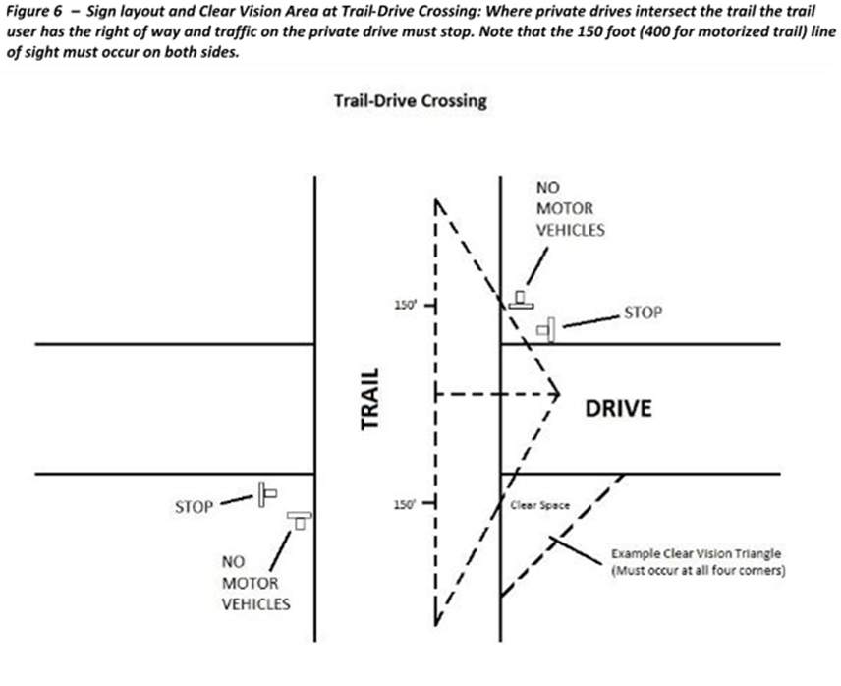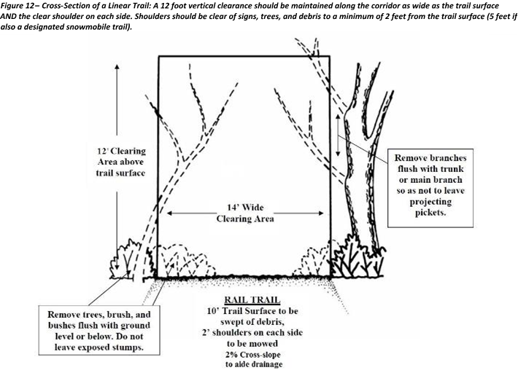

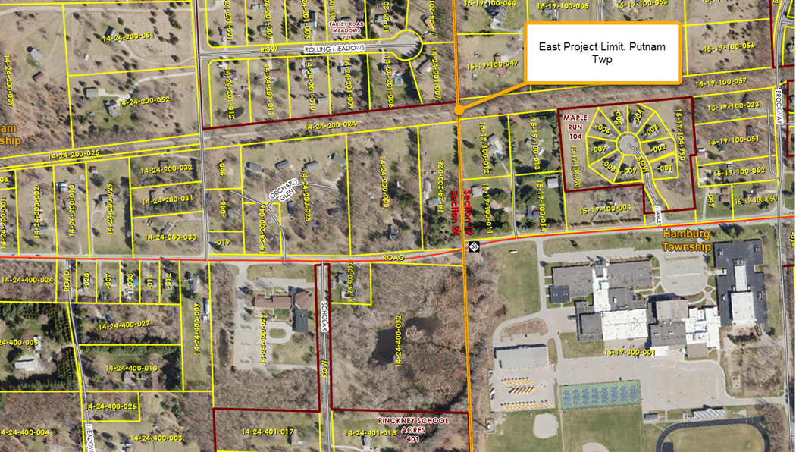
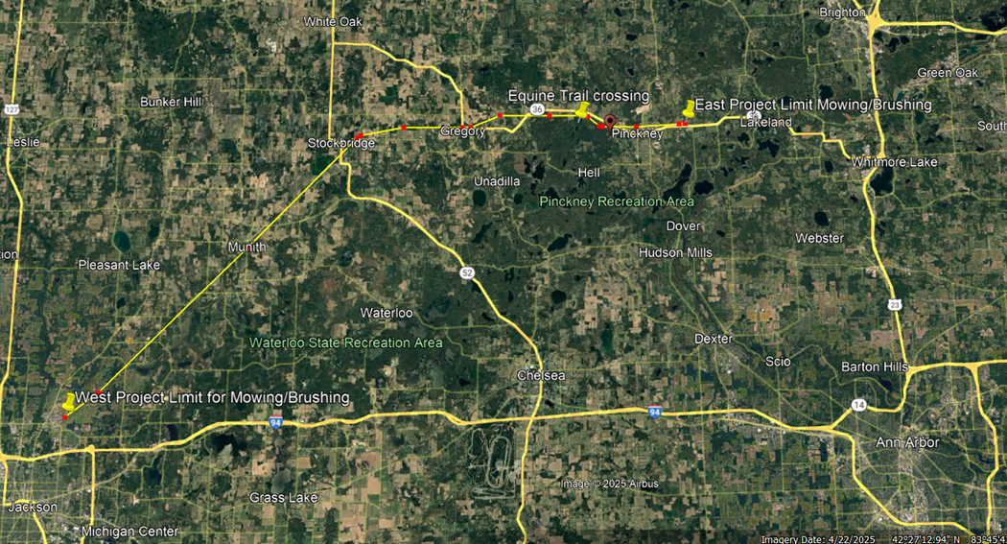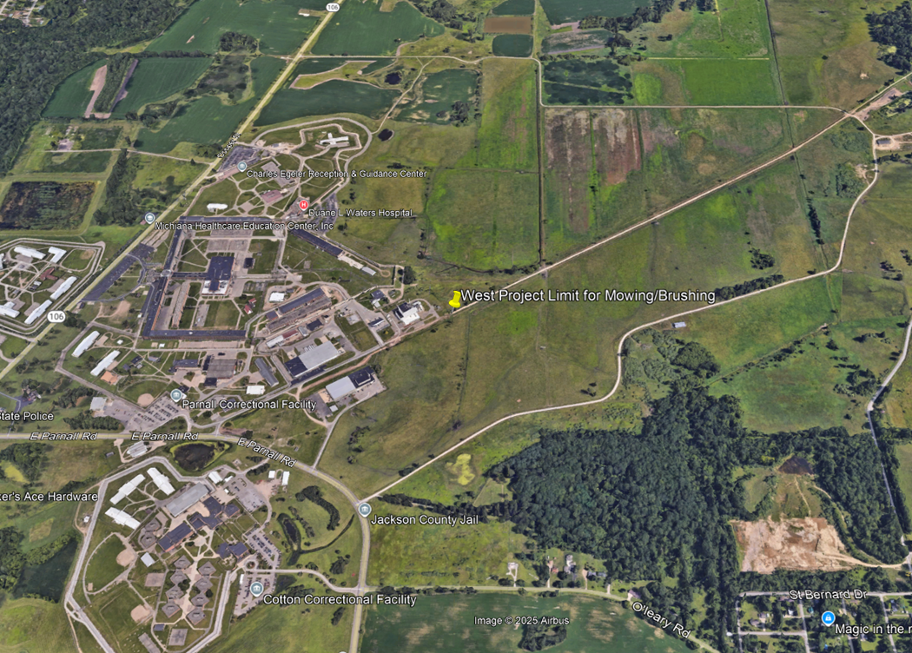

Enter company name here

Schedule B - Pricing
Request For Proposal No. 260000000891
Brush Clearing and Mowing of trails at Mike Levine Lakeland Trail State Park
- The Contractor must provide a pricing schedule for the proposed Contract Activities using .The pricing schedule should be submitted in a modifiable format (e.g. Microsoft Word or Excel); however, you may also submit an additional pricing schedule in a non-modifiable format (e.g., PDF). Failure to complete the pricing schedule as requested may result in disqualification of your proposal.
- Price proposals must include all costs, including but not limited to, any one-time or set-up charges, fees, and potential costs that Contractor may charge the State (e.g., shipping and handling, per piece pricing, and palletizing).
- The Contractor is encouraged to offer quick payment terms. The number of days must not include processing time for payment to be received by the Contractor's financial institution.
- Quick payment terms: % discount off invoice if paid within days after receipt of invoice.
- By submitting its proposal, the Contractor certifies that the prices were arrived at independently, and without consultation, communication, or agreement with any other Contractor.
Pricing Sheet:

Site Descriptions of Brushing/Mowing: | Unit Price | # of Brushings Needed per Year | Total Cost per Year
Brushing and Tree Limb Clearing:  One time annually in the fall between September 15 to September 30th.  Trim brush to a height of 12 feet.  Cut back existing brush along trail edges a minimum of five feet to allow for mowing equipment to pass through and to keep brush back off trail. (See figure 12 in Exhibit A).  Clear sight lines at intersections will be established and maintained. (See figure 6 in Exhibit A).  Blow debris off trail surface and two-foot shoulders. | $0.00 per brushing | 1 | $0.00
Mowing and Weed whipping:  Mow trail shoulders one time per month from May to September.  Mowing will take place mid-month, between the 10th and 20th of each month.  Weed whip around all benches, signs, fences, porta-johns, etc. within five feet of the trail edge. Excluding the signs on Prison Property “Prison Property No Trespassing”  Clear sight lines at intersections will be established and maintained. | $0.00 per mowing and weed whipping | 5 | $0.00
Total 1 Year Service Fee |  |  | $0.00
Years in Contract Term |  |  | 3 years with 2, 1-year options
(Multiply line 1 and 2) Total Contract Term Service Fee (3 yrs) |  |  | $0.00

